# Terraform Workspaces and Staging

# 

## Tutorial

### Workspace

Using previous tutorial directory

Create new workspace

$ terraform workspace new production

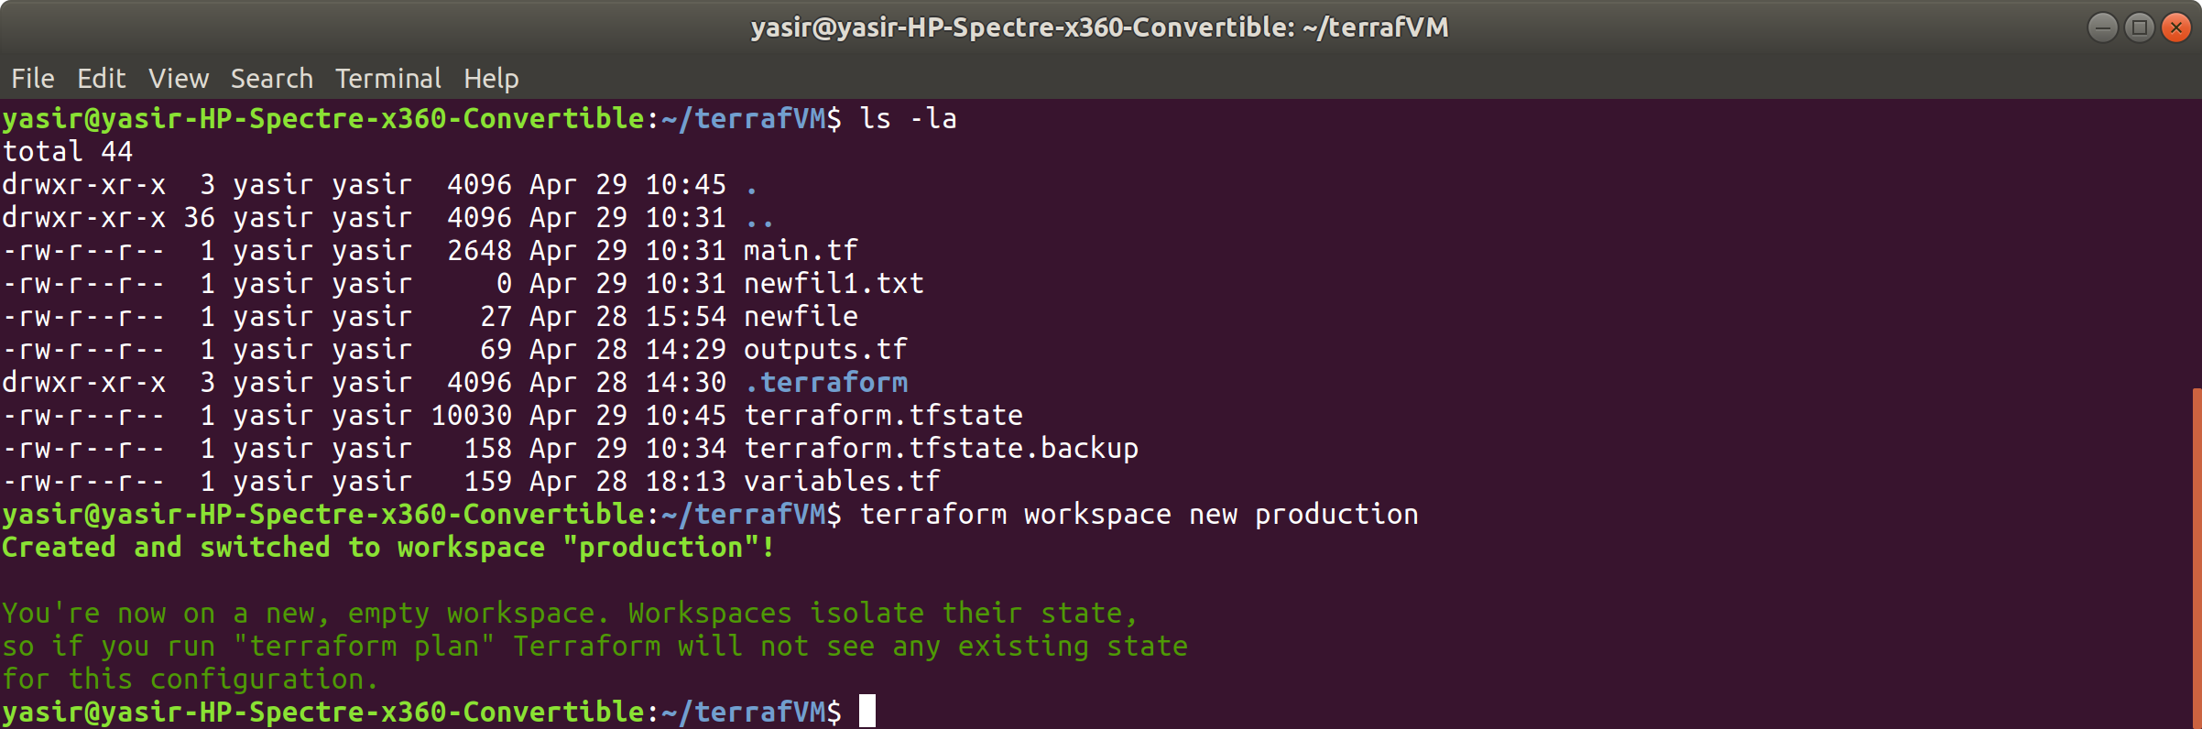

new directory named “terrafrom.tfstate.d created

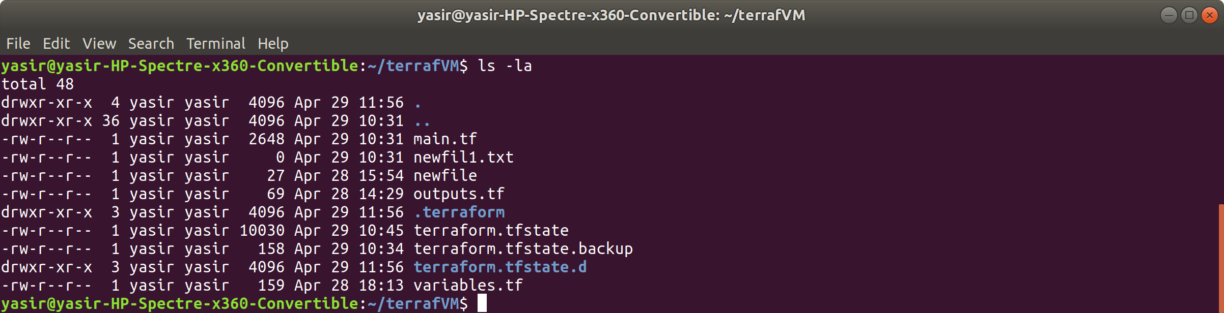

### Production and Staging

Create new workspace named “staging”

$ terraform workspace new staging

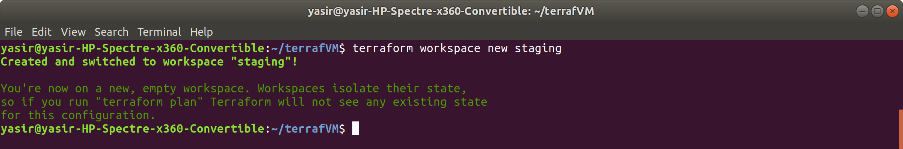

Switch to workspace “production”

$ terraform workspace select production



In variable.tf file remove the variable “prefix” block to contain as follows

variable "admin_username" {

default = "yasirsatti"

}

variable "admin_password" {

default = "Password1234!"

}

$ vim variable

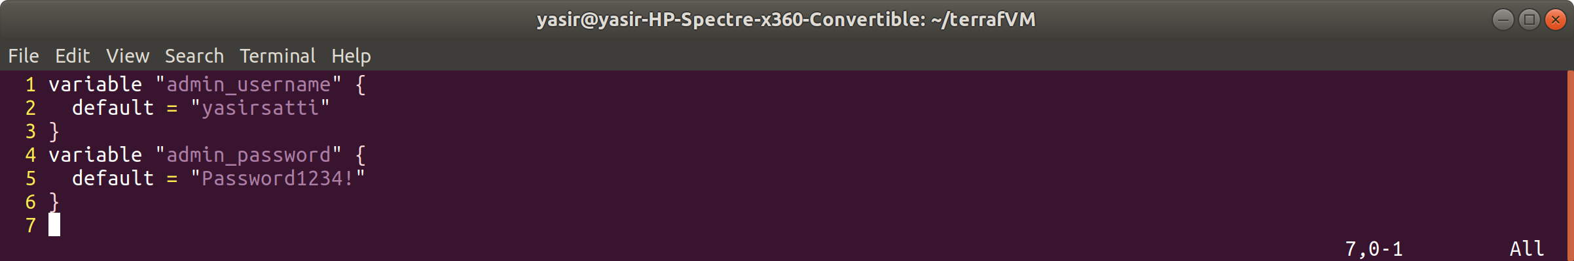

In main.tf file replace “var.prefix” with “terraform.workspace”

# Configure the provider.

provider "azurerm" {

version = "2.0.0"

features {}

}

resource "azurerm_resource_group" "main" {

name = "${terraform.workspace}-resources"

location = "East US 2"

}

resource "azurerm_virtual_network" "main" {

name = "${terraform.workspace}-network"

address_space = ["10.0.0.0/16"]

location = azurerm_resource_group.main.location

resource_group_name = azurerm_resource_group.main.name

}

resource "azurerm_subnet" "internal" {

name = "internal"

resource_group_name = azurerm_resource_group.main.name

virtual_network_name = azurerm_virtual_network.main.name

address_prefix = "10.0.2.0/24"

}

resource "azurerm_public_ip" "main" {

name = "${terraform.workspace}-PublicIp"

location = azurerm_resource_group.main.location

resource_group_name = azurerm_resource_group.main.name

allocation_method = "Static"

}

resource "azurerm_network_interface" "main" {

name = "${terraform.workspace}-nic"

location = azurerm_resource_group.main.location

resource_group_name = azurerm_resource_group.main.name

ip_configuration {

name = "testconfiguration1"

subnet_id = azurerm_subnet.internal.id

private_ip_address_allocation = "Dynamic"

public_ip_address_id = azurerm_public_ip.main.id

}

}

resource "azurerm_virtual_machine" "main" {

name = "${terraform.workspace}-vm"

location = azurerm_resource_group.main.location

resource_group_name = azurerm_resource_group.main.name

network_interface_ids = [azurerm_network_interface.main.id]

vm_size = "Standard_DS1_v2"

storage_image_reference {

publisher = "Canonical"

offer = "UbuntuServer"

sku = "16.04-LTS"

version = "latest"

}

storage_os_disk {

name = "myosdisk1"

caching = "ReadWrite"

create_option = "FromImage"

managed_disk_type = "Standard_LRS"

}

os_profile {

computer_name = "hostname"

admin_username = var.admin_username

admin_password = var.admin_password

}

os_profile_linux_config {

disable_password_authentication = true

ssh_keys {

key_data = file("~/.ssh/id_rsa.pub")

path = "/home/${var.admin_username}/.ssh/authorized_keys"

}

}

provisioner "file" {

connection {

host = azurerm_public_ip.main.ip_address

type = "ssh"

user = var.admin_username

private_key = file("~/.ssh/id_rsa")

}

source = "~/.ssh/id_rsa.pub"

destination = "public-key"

}

}

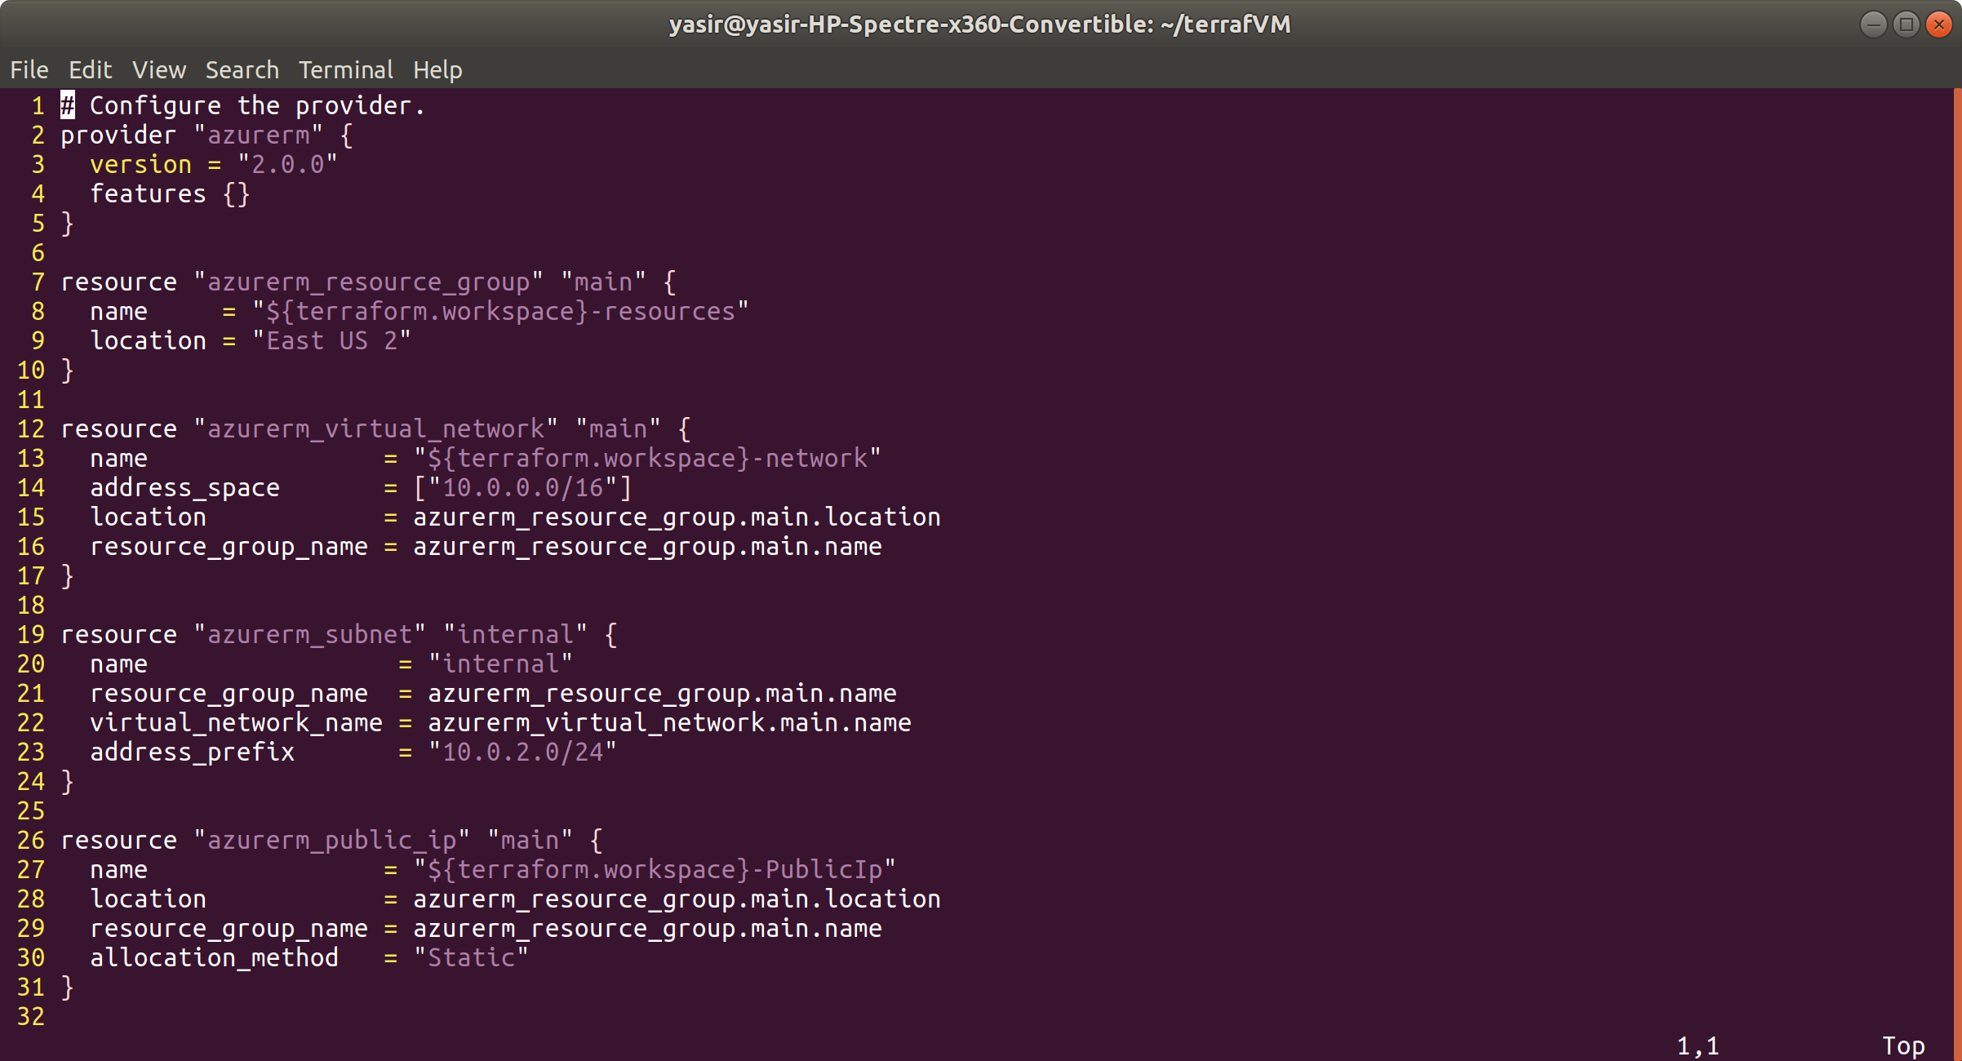

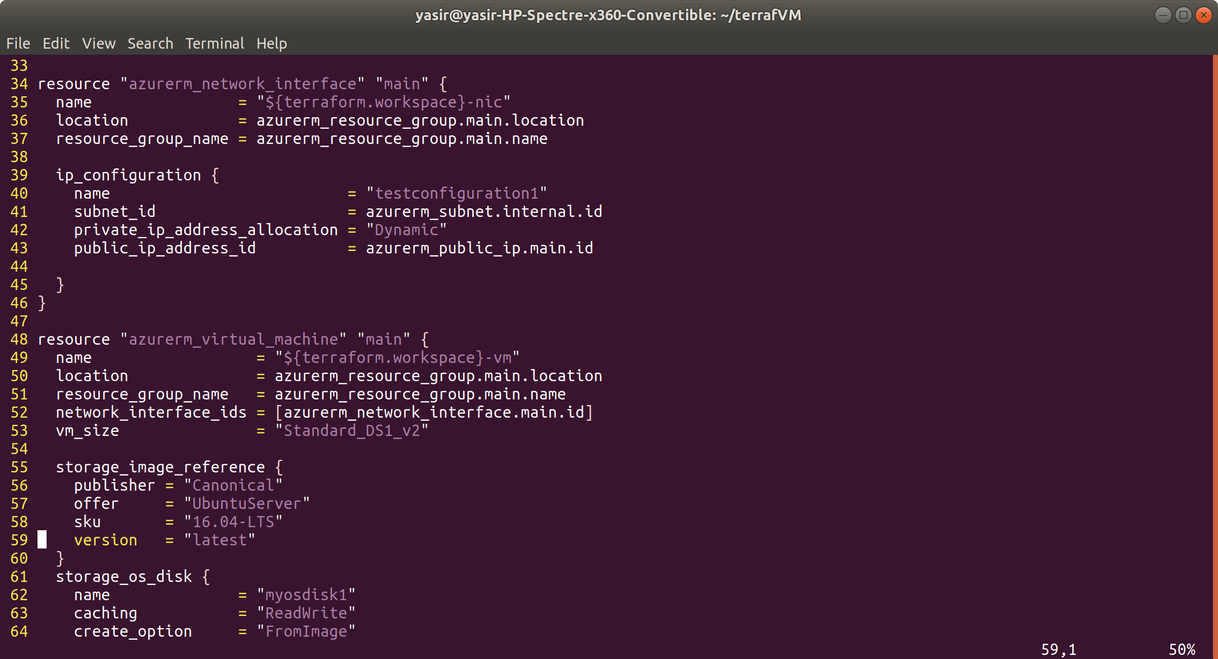

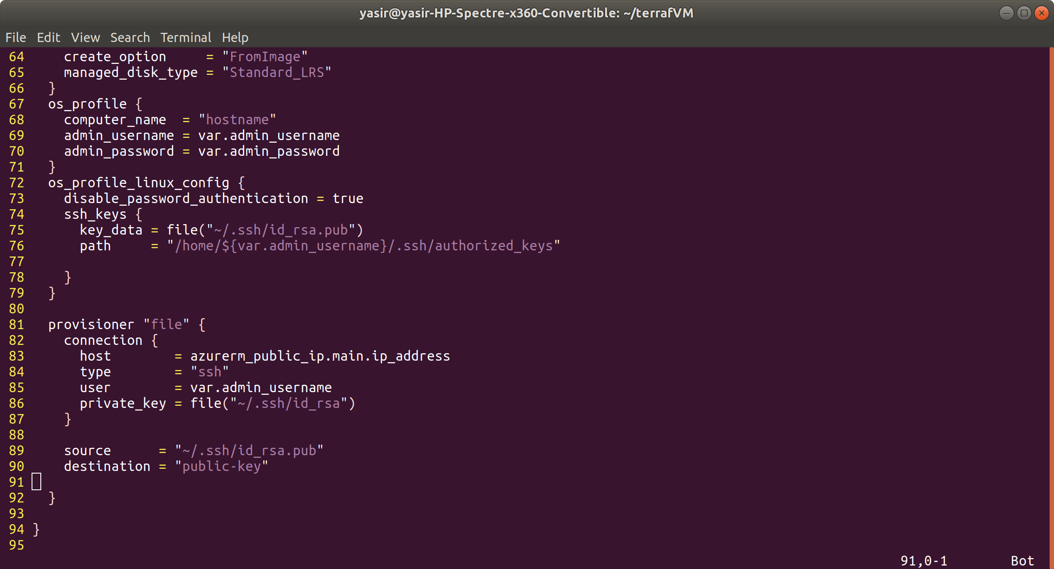

Initialize terraform

$ terraform init

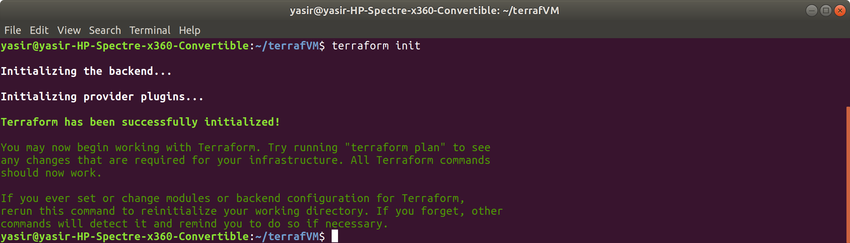

format files

$ terraform fmt



validate configuration

$ terraform validate

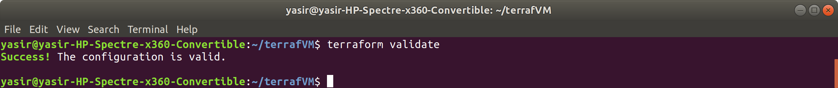

Apply the plan

$ terraform apply

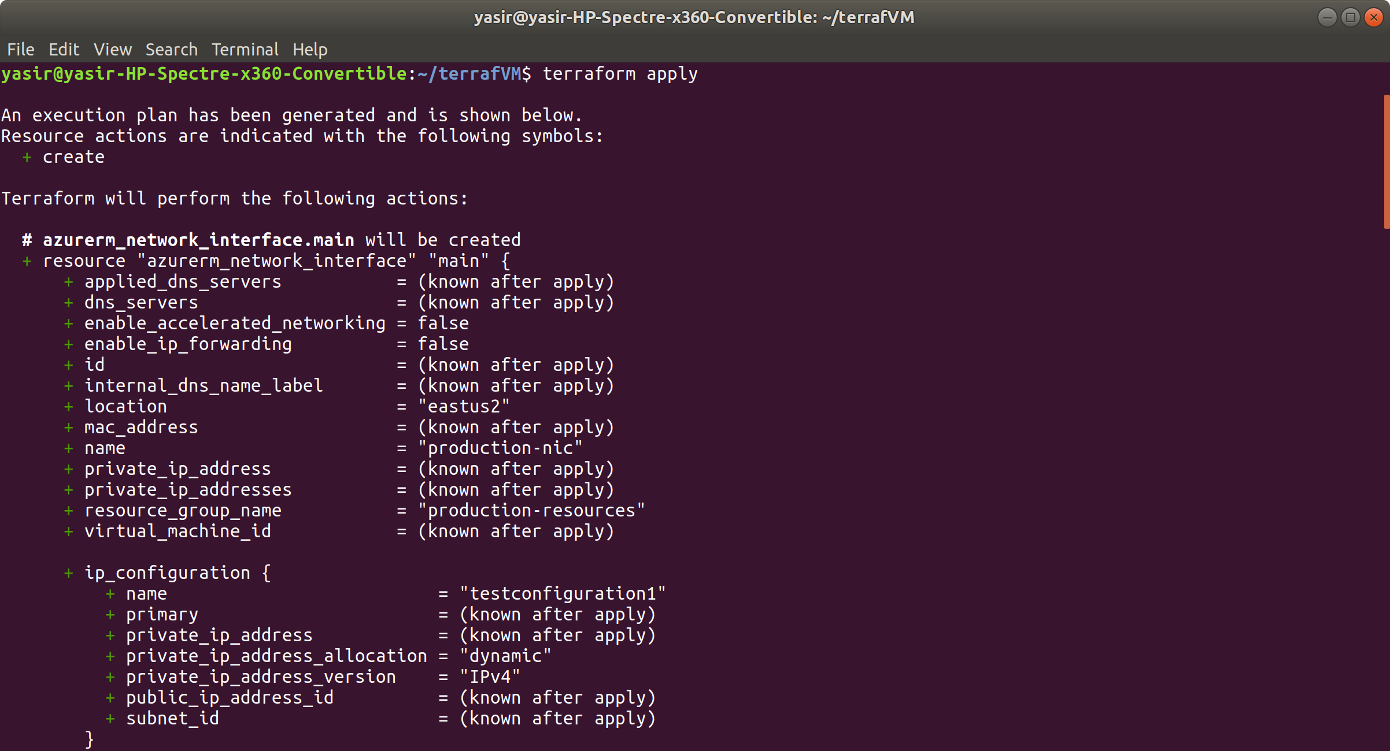

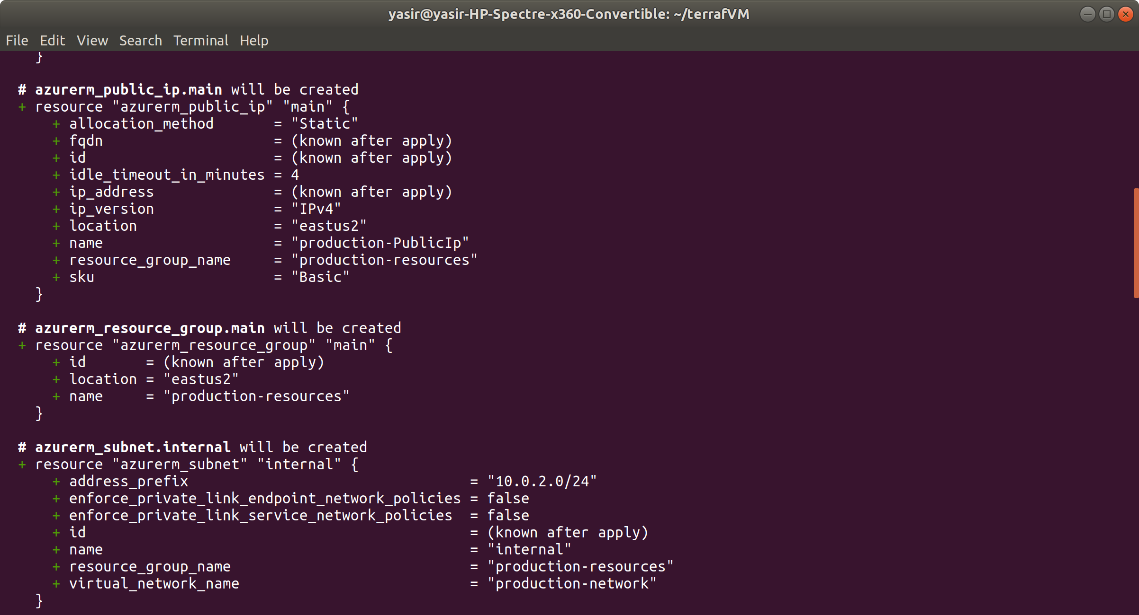

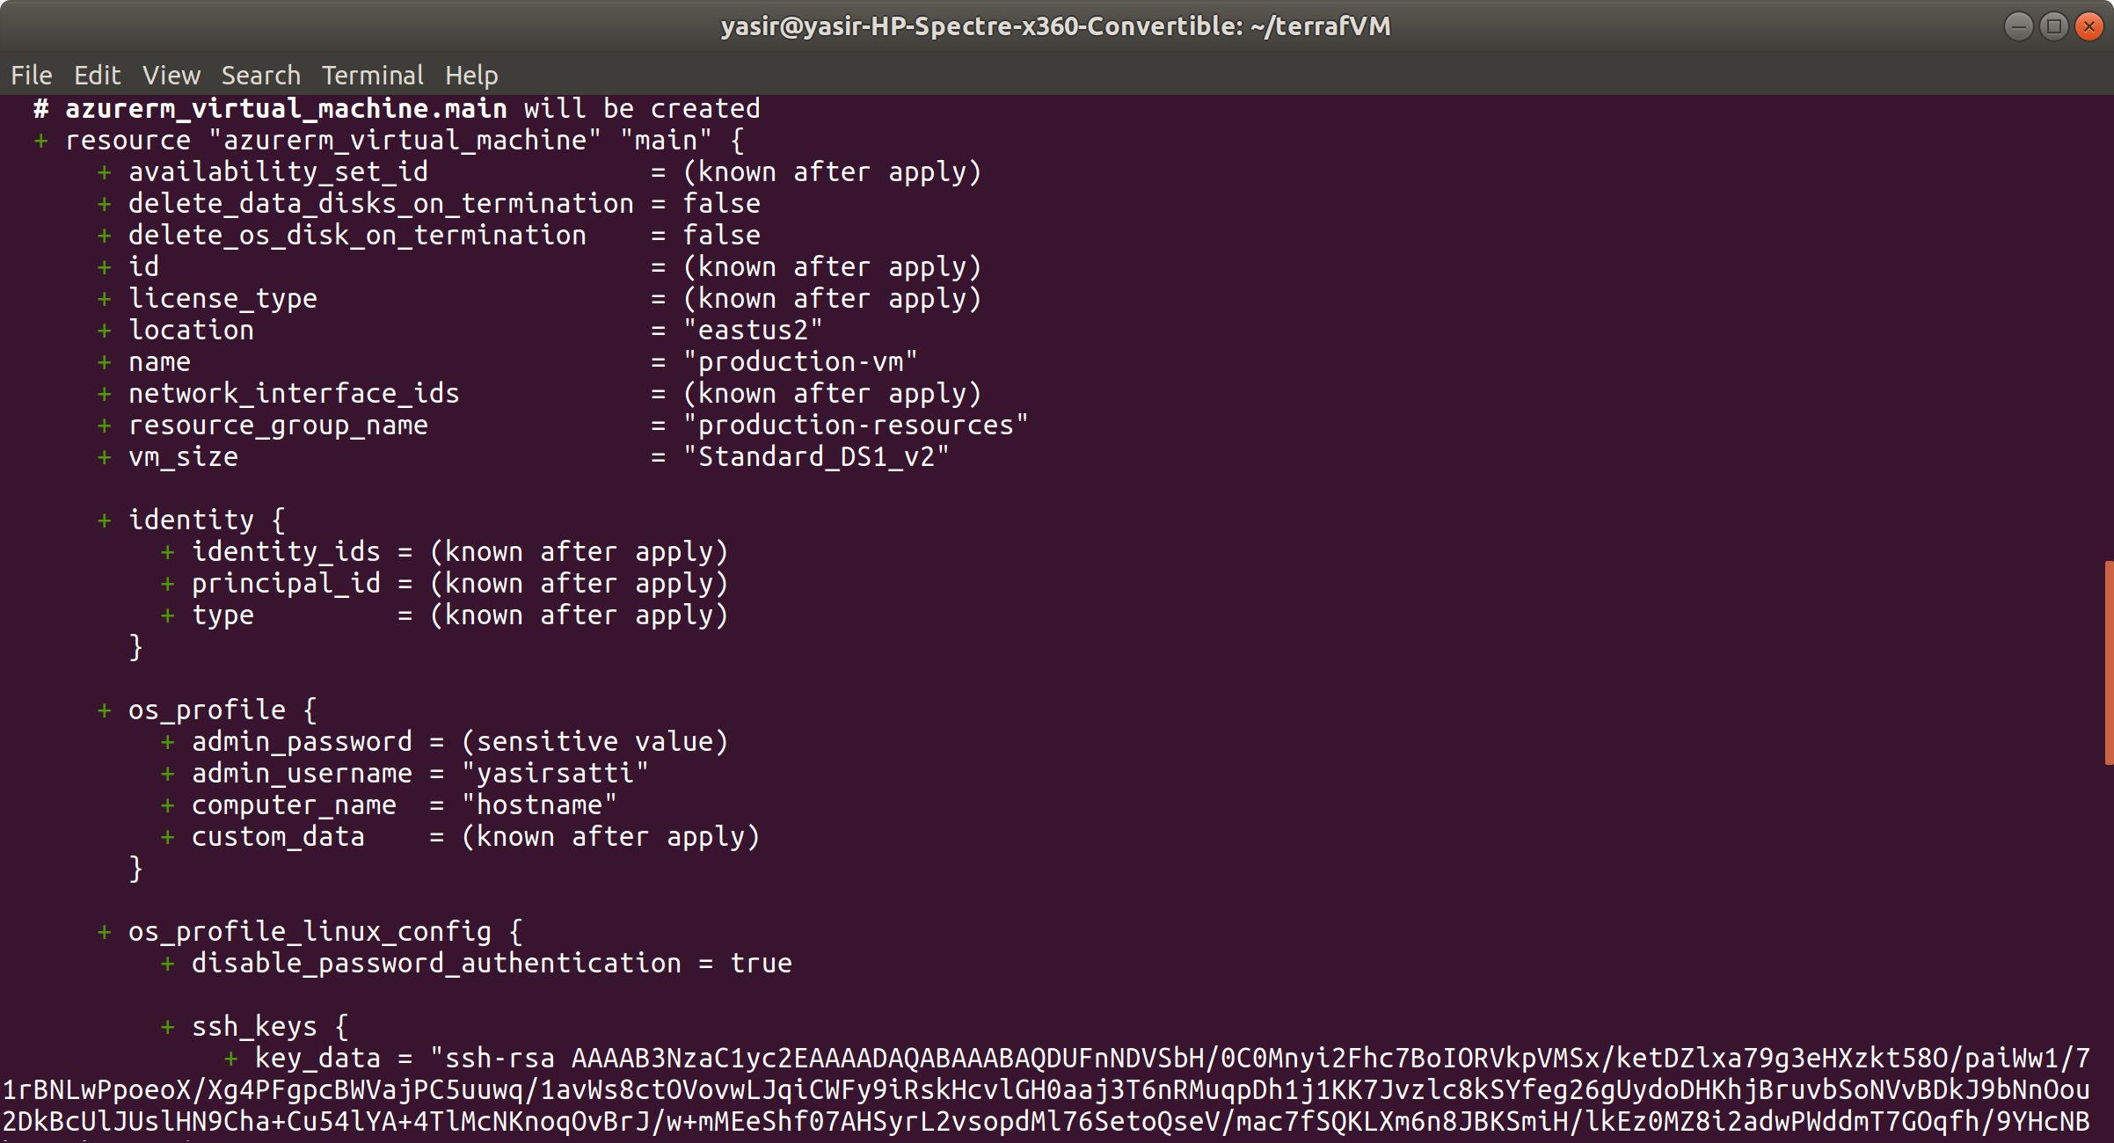

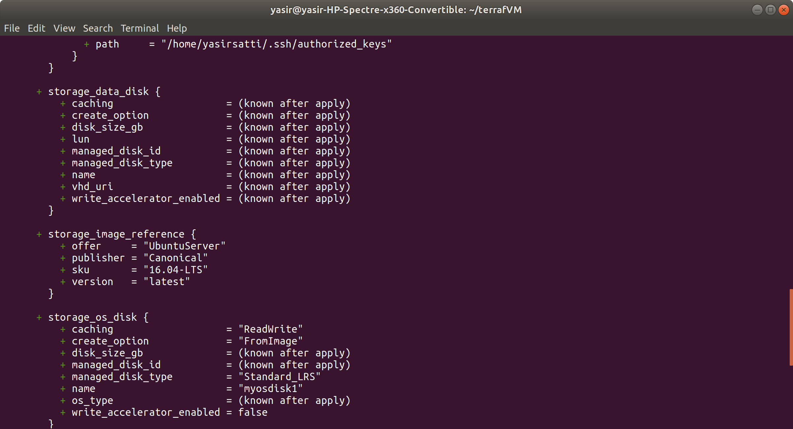

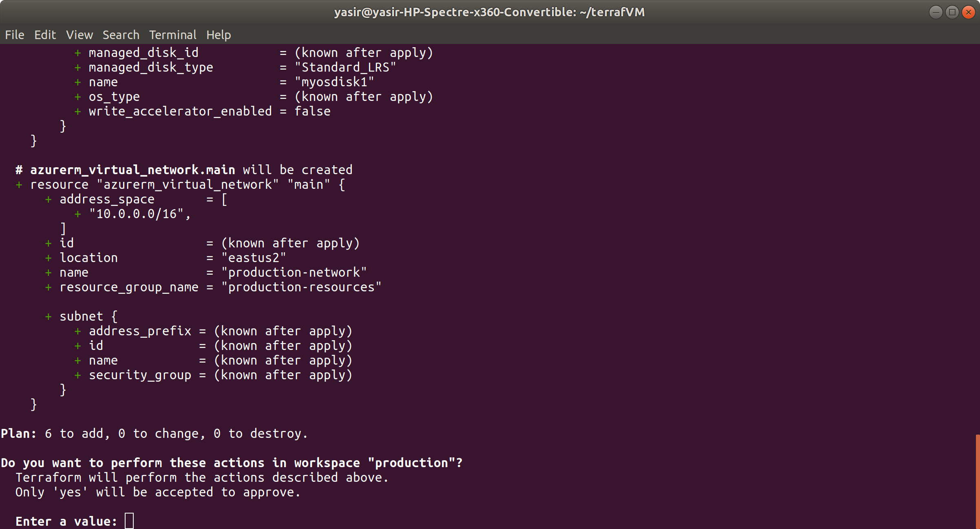

Type yes to accept plan

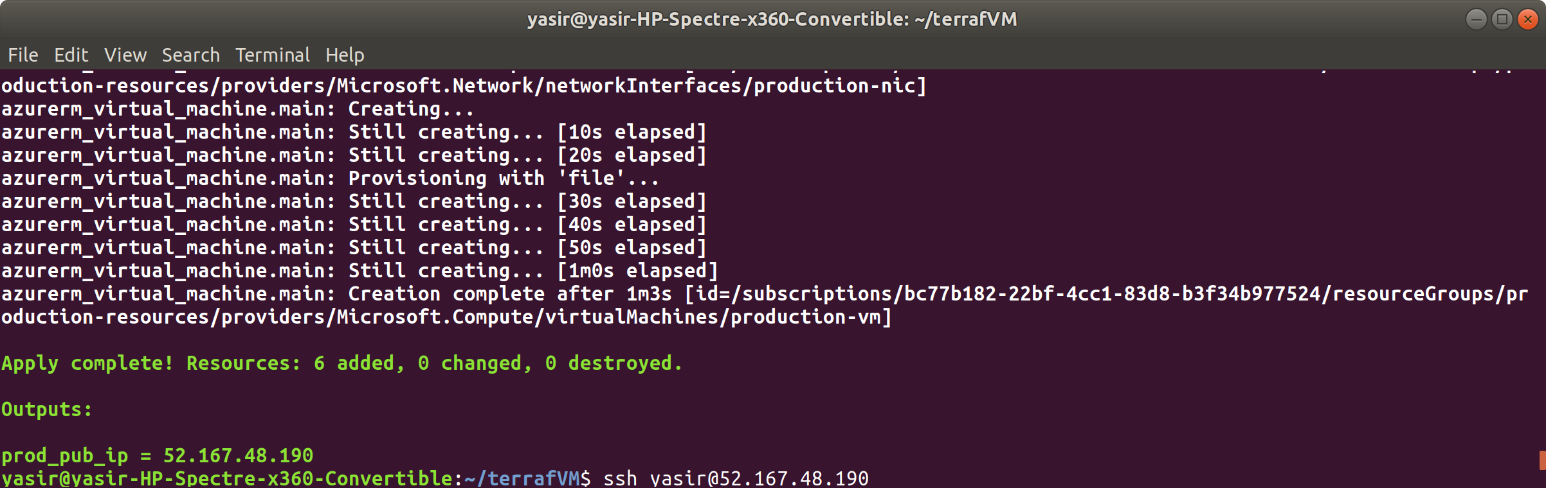

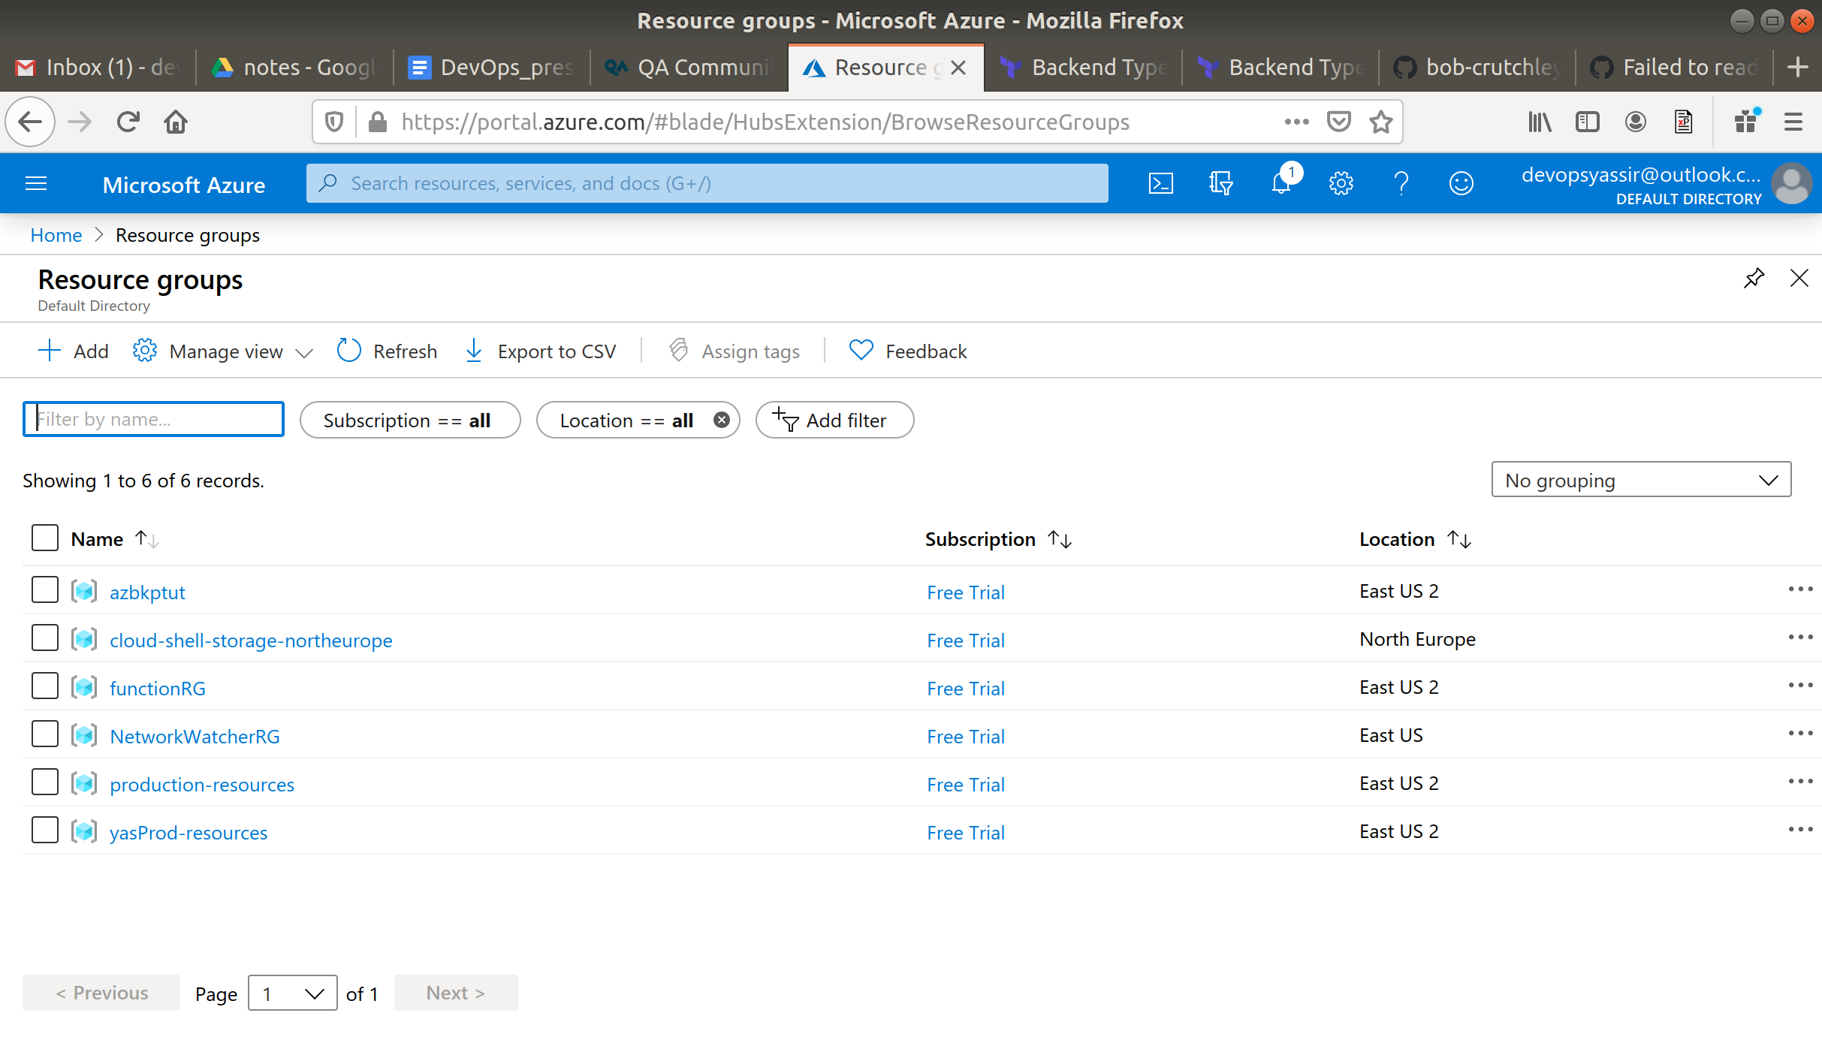

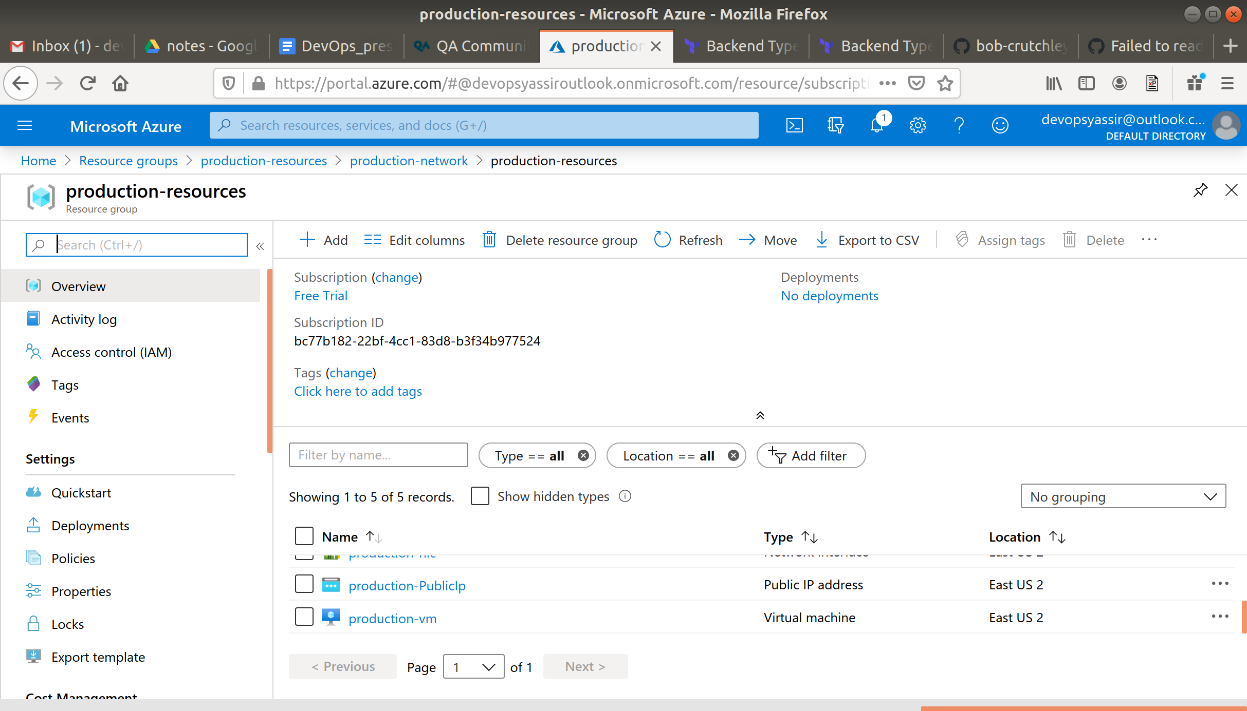

Now ssh to the VM and check for the public-key file

$ ssh yasirsatti@$(terraform output prod_pub_ip)

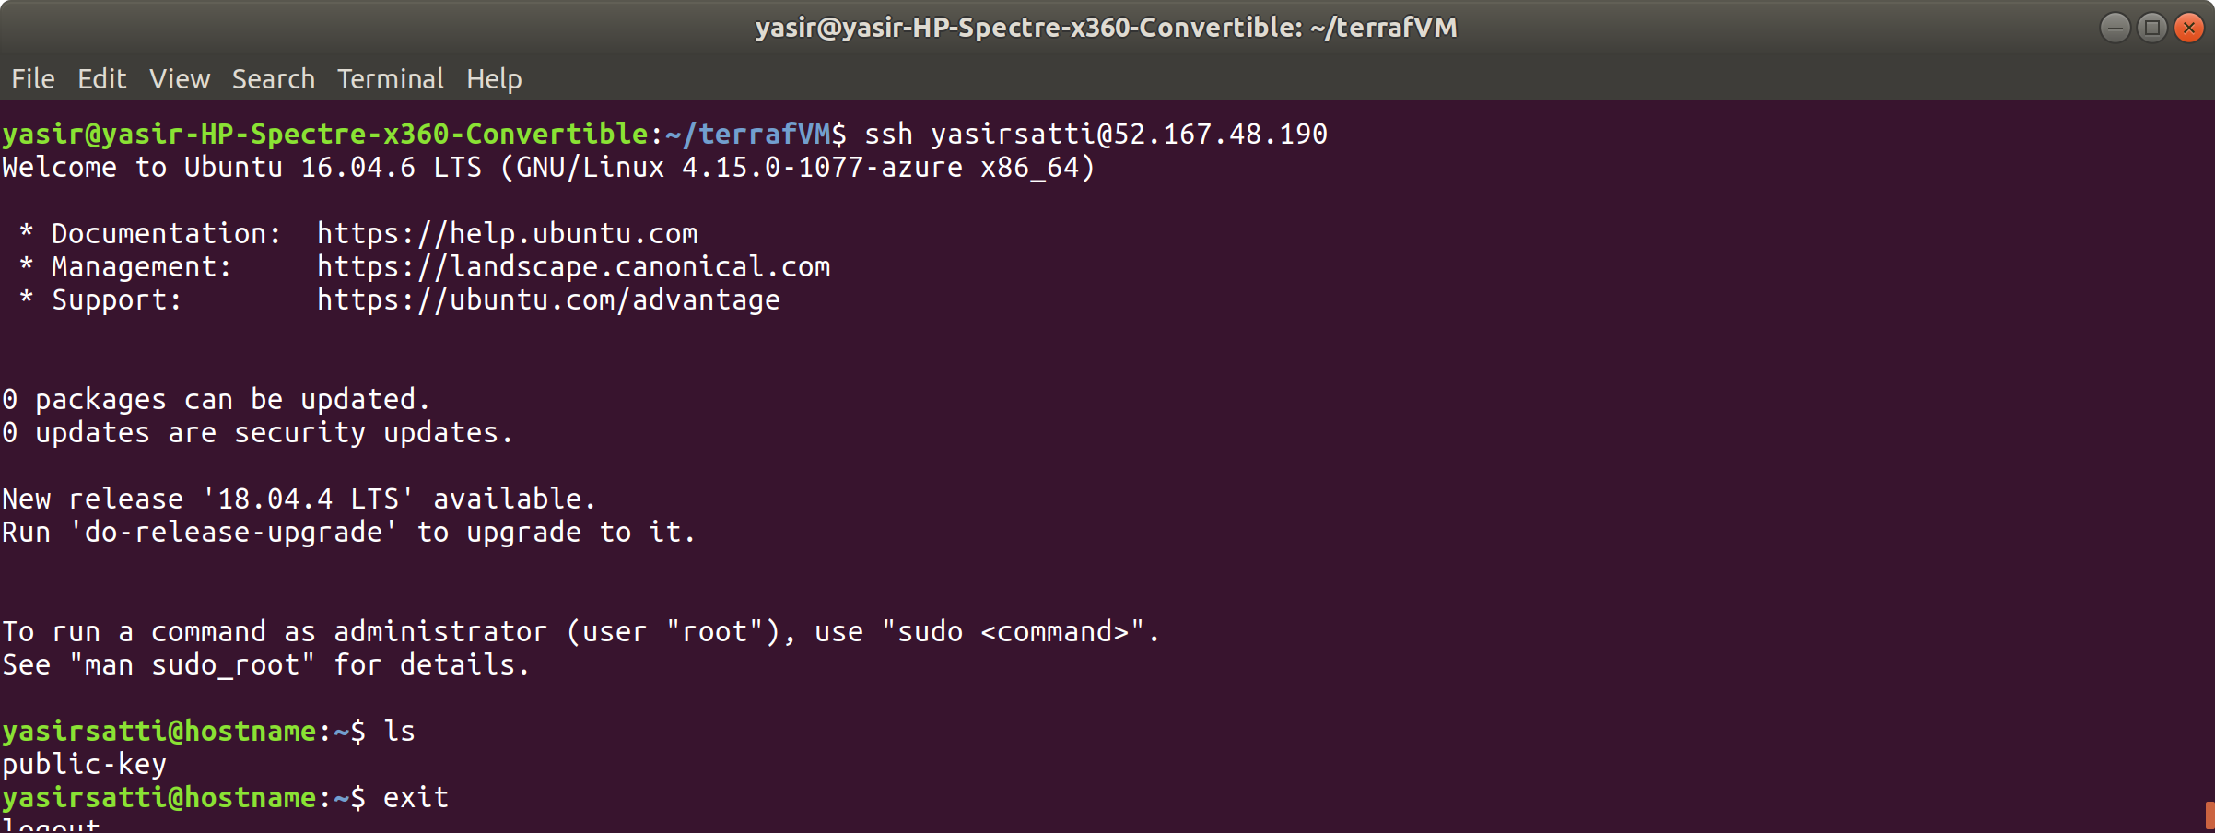

Now switch workspace to “staging”

$ terraform workspace select staging

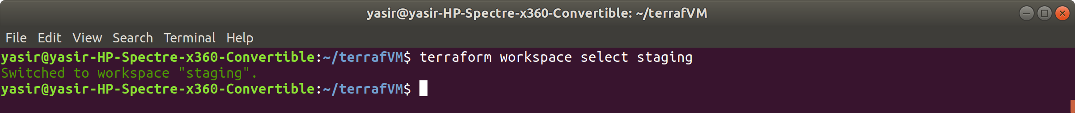

Now run apply again

$ terraform apply

notice the resource group name changed from “production” to staging”

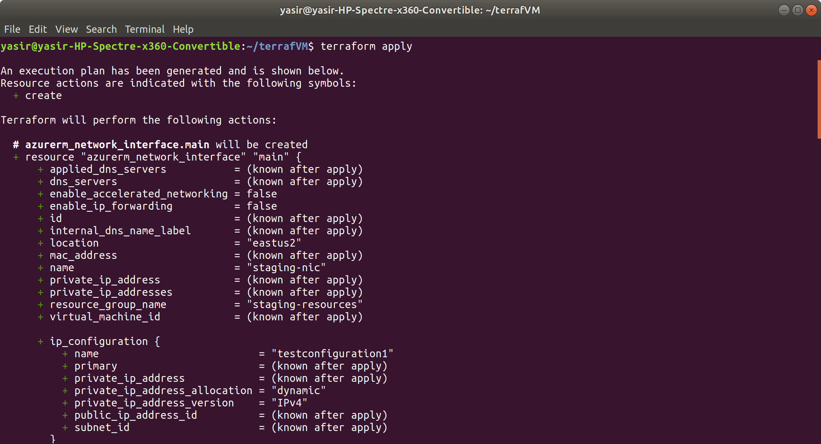

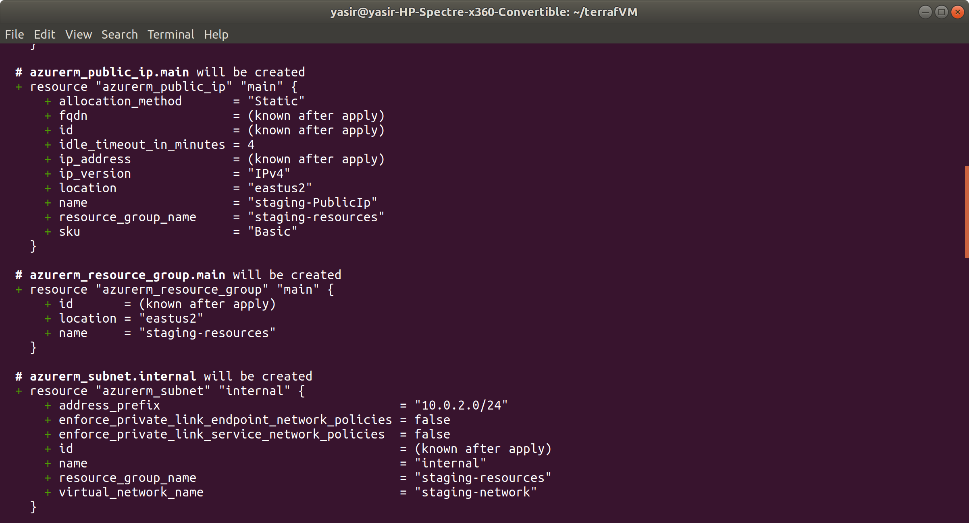

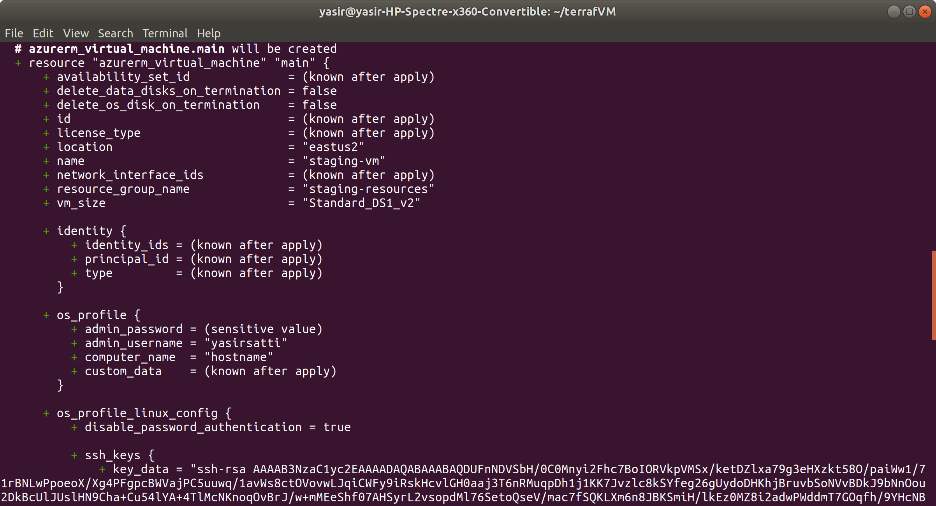

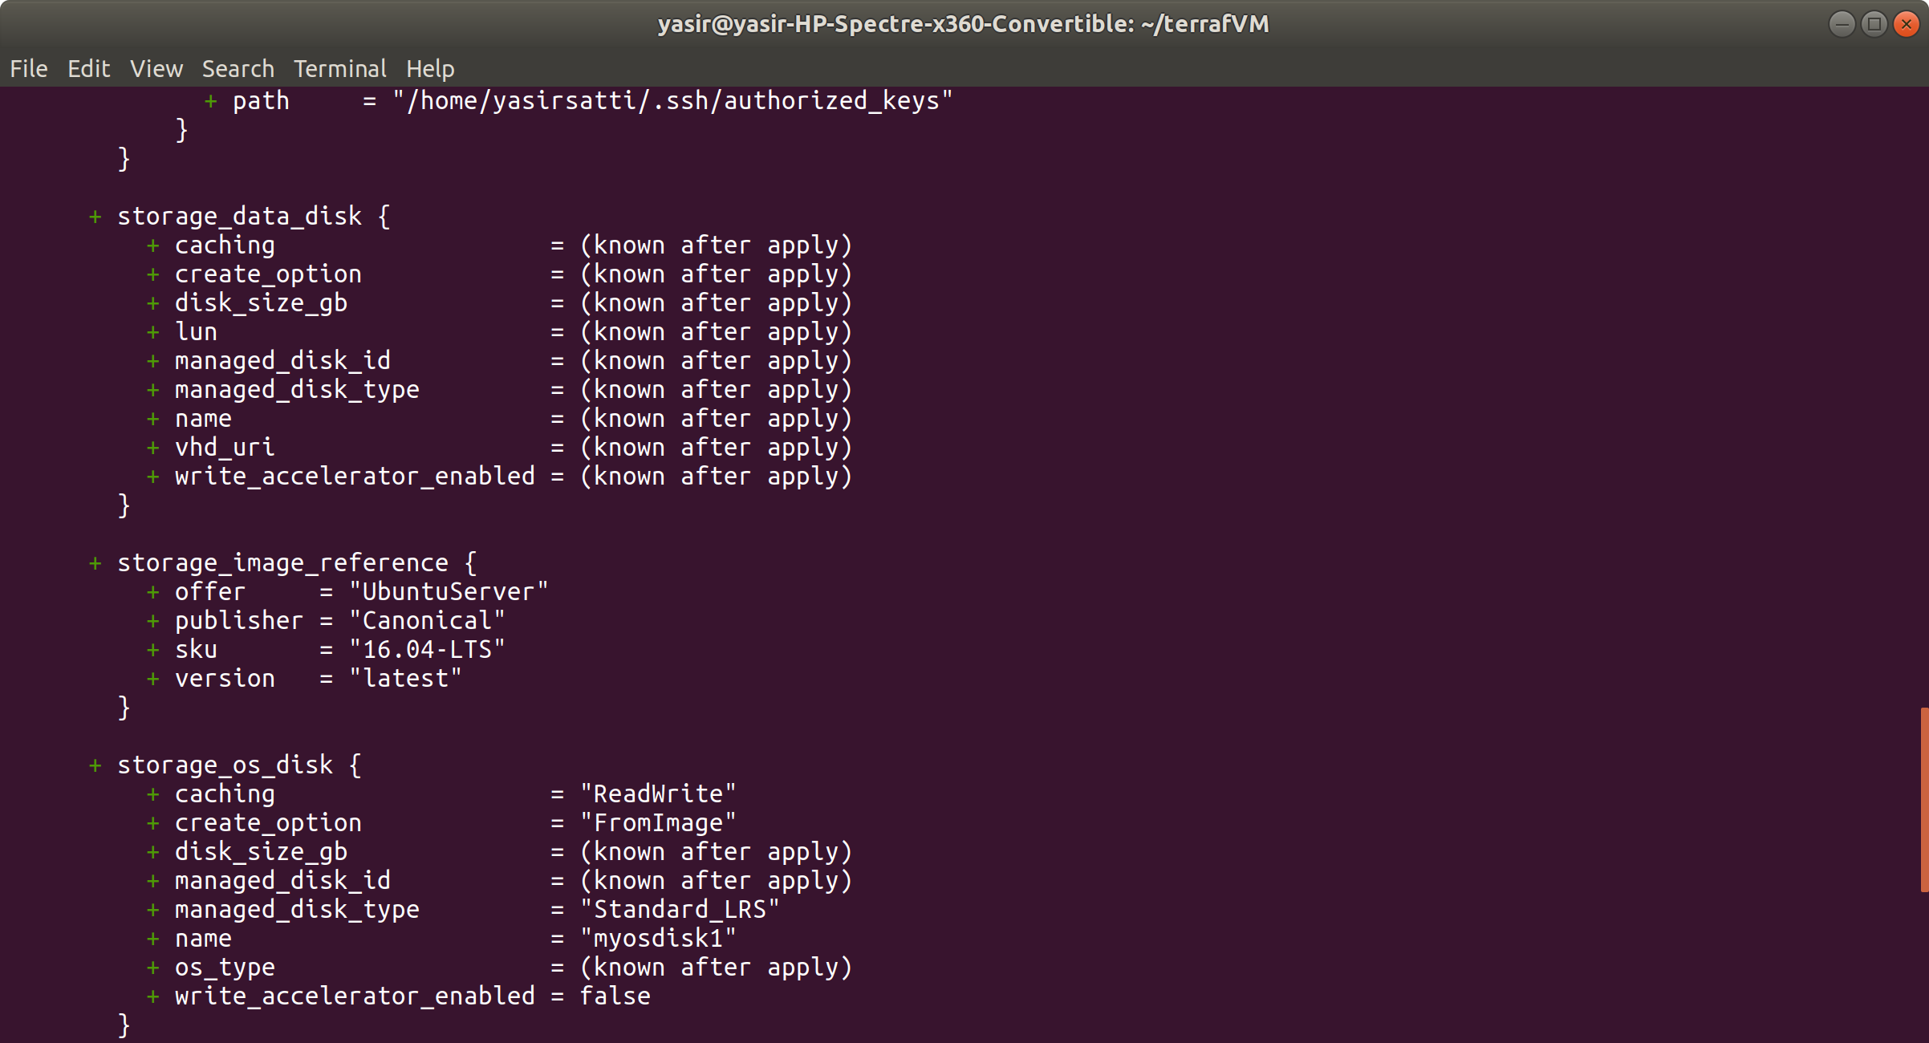

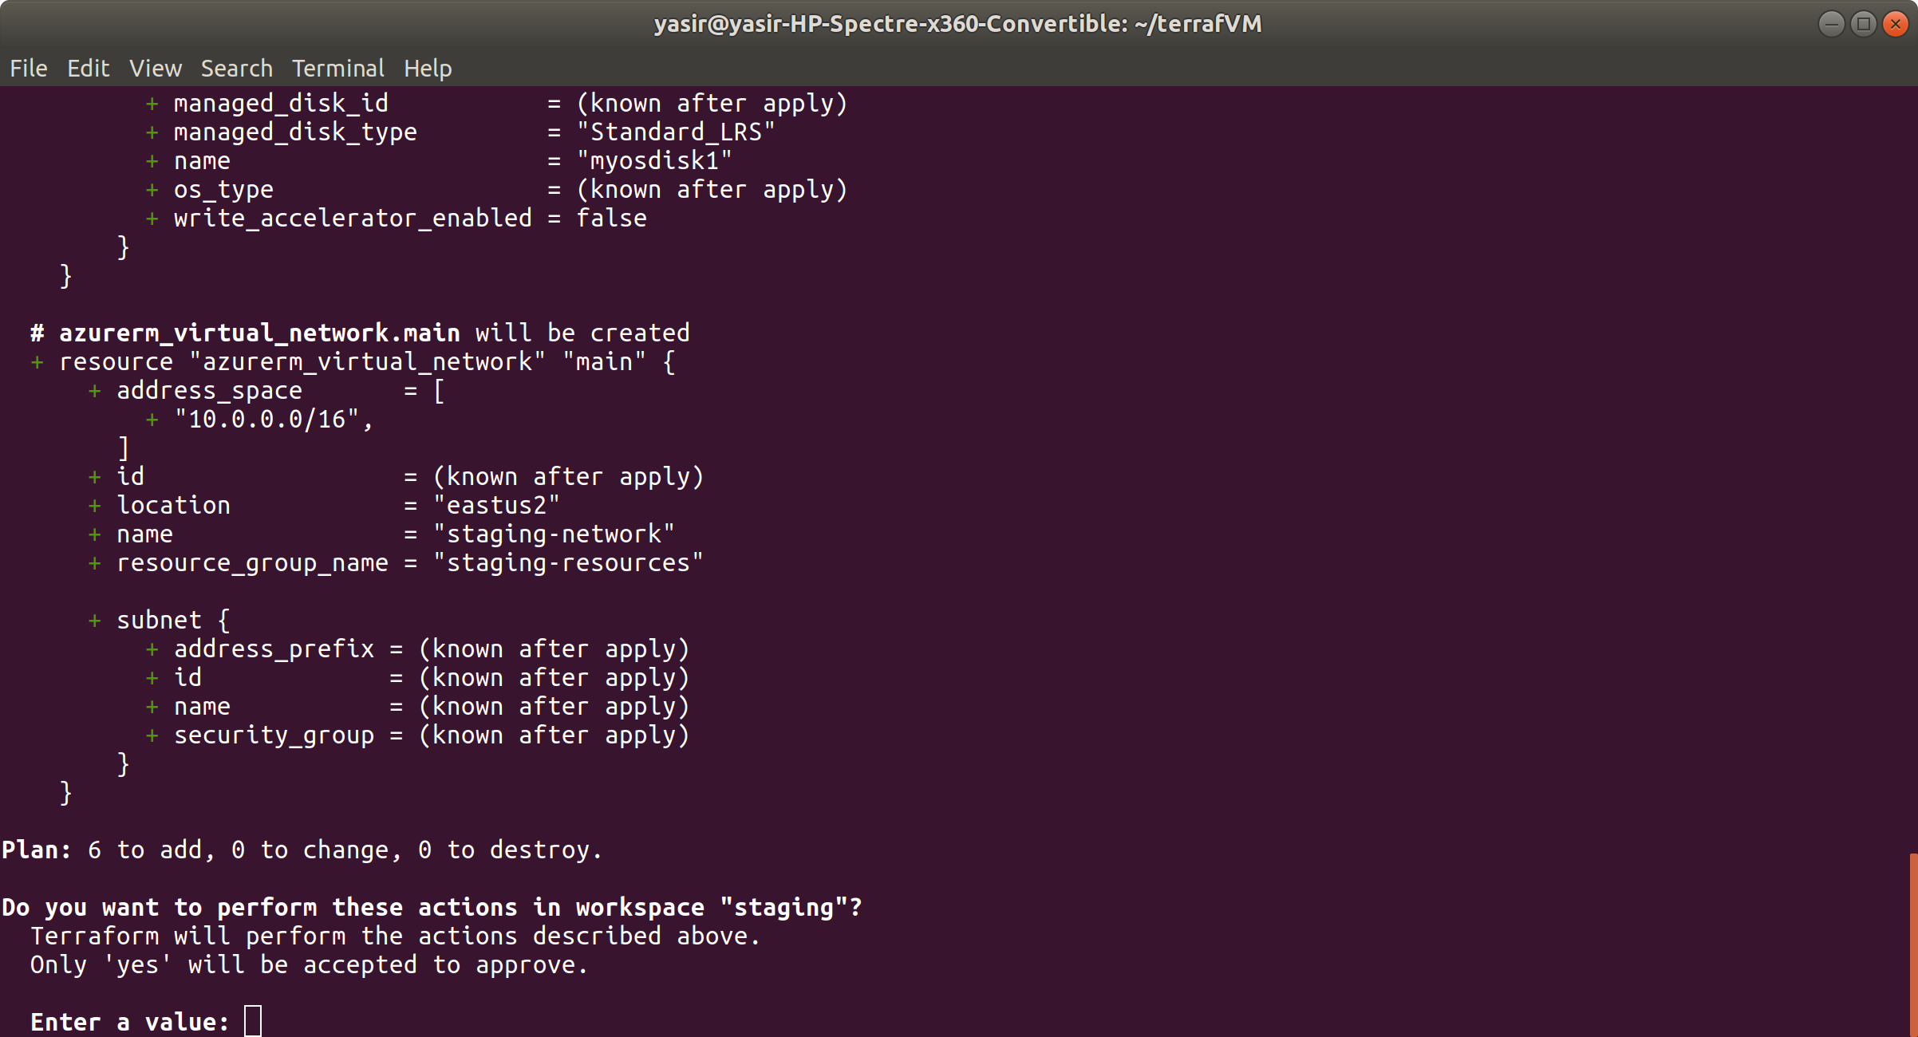

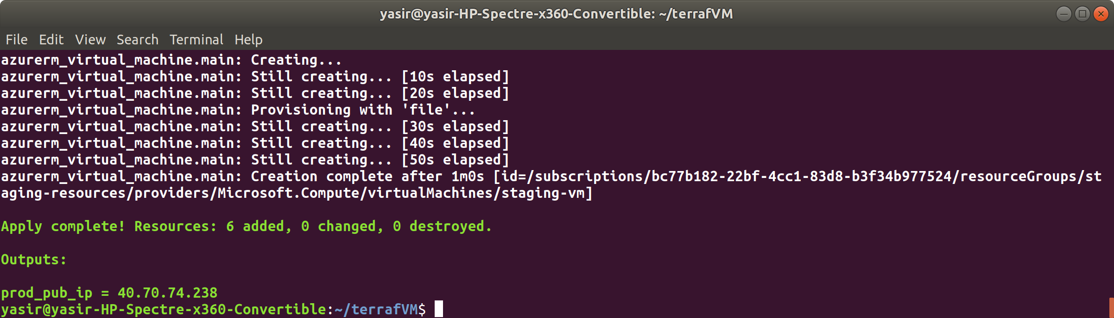

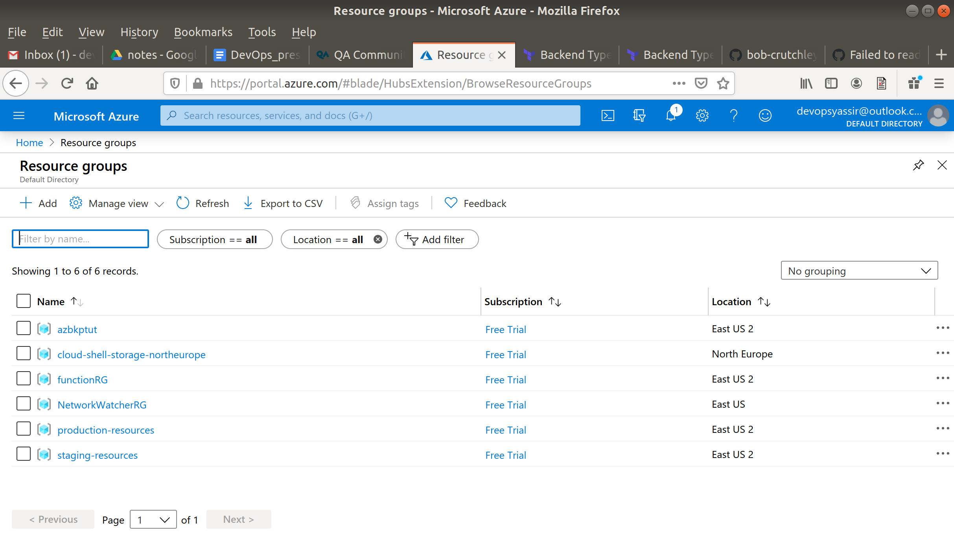

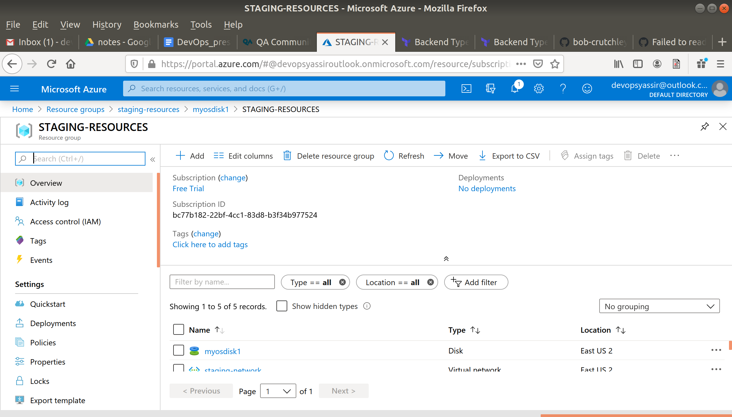

Now notice what happens if you try to apply the plan again in the staging workspace

$ terraform apply

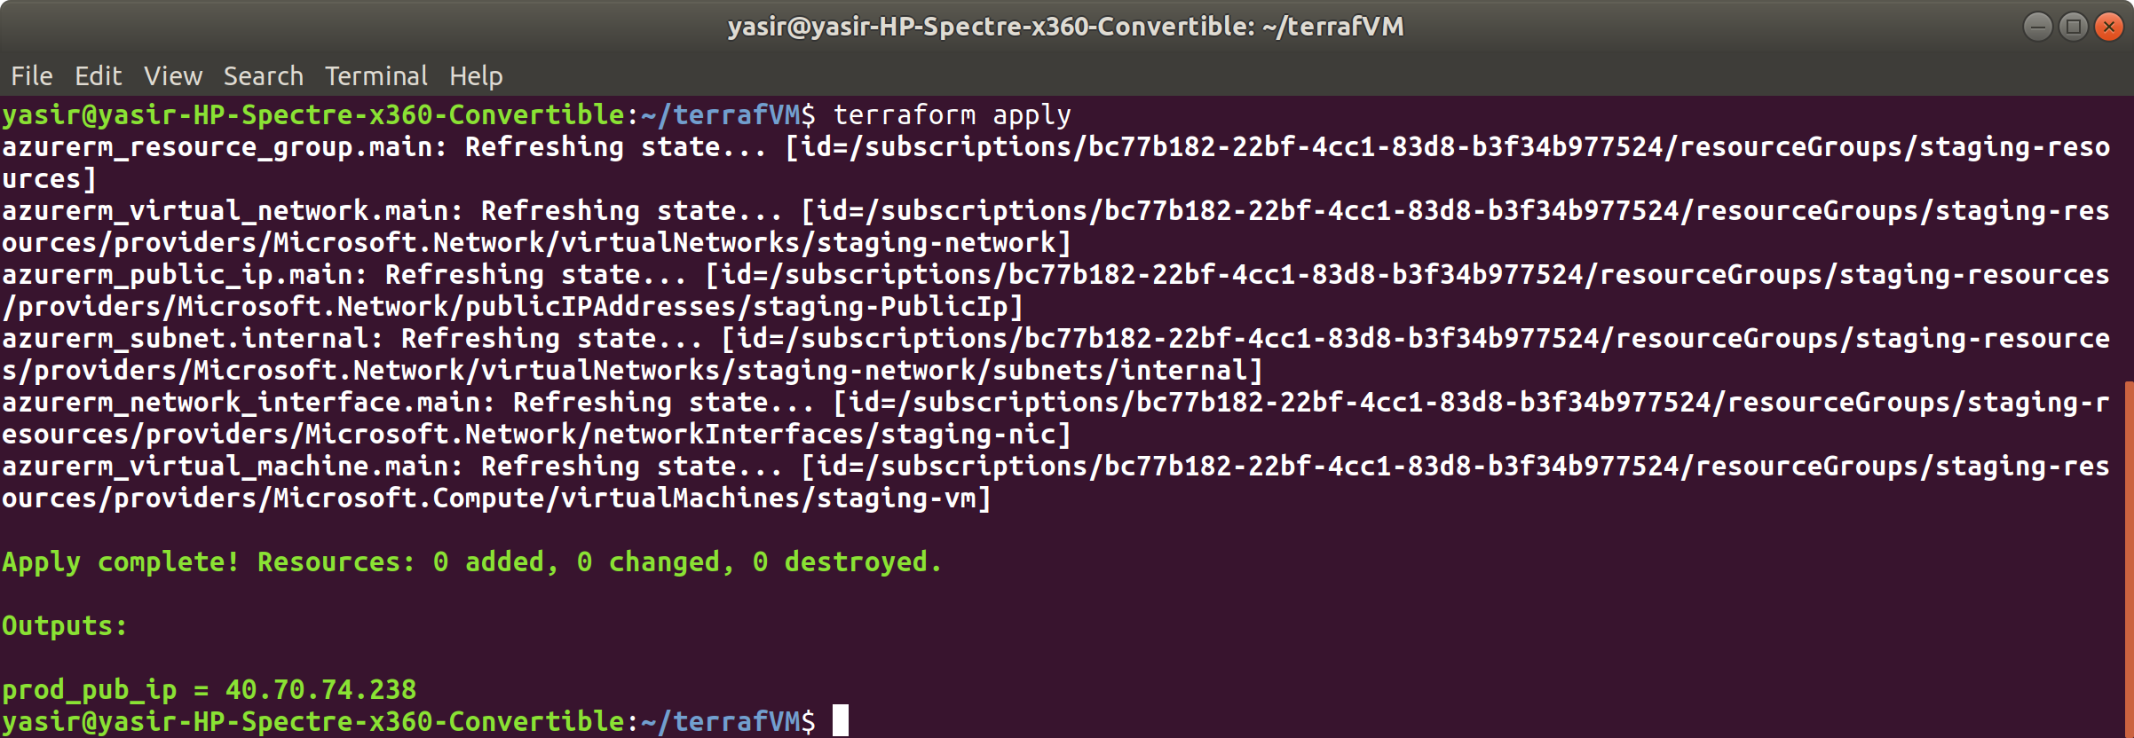

It knows the resources are already there and up so no need to create them

Switch to production workspace and try

$ terraform workspace select production && terraform apply

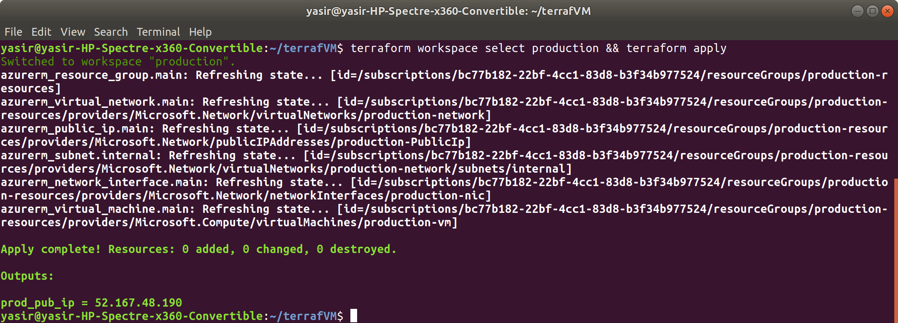

same result.

The reason is it remembers this using the state files and folder in the root

$ ls -la

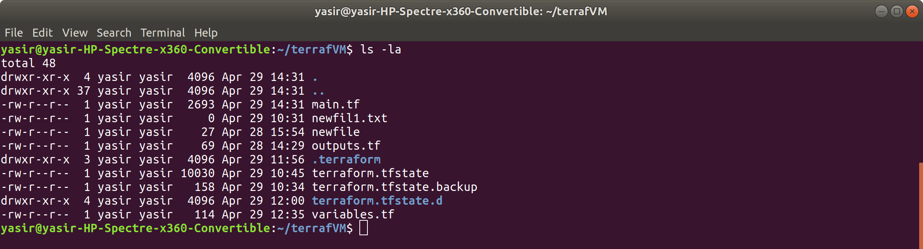

terraform.tfstate

terraform.tfstate.backup

The folder terraform.tfstate.d holds the necessary files to remember running resources

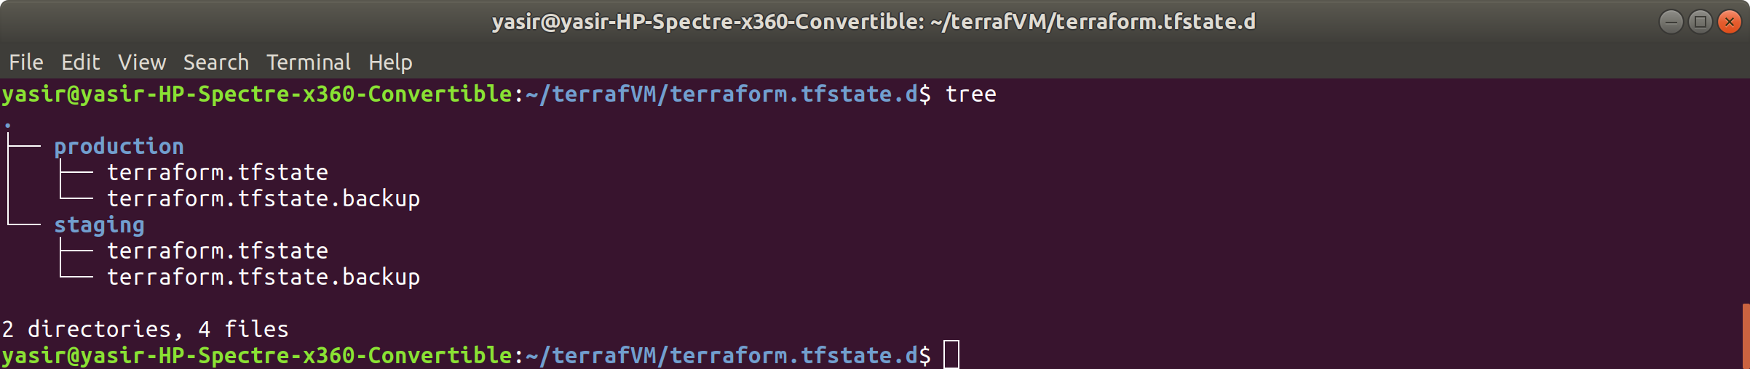

These files and folder could be stored remotely and referenced. For more see [here](https://www.terraform.io/docs/backends/types/remote.html#workspaces)